# DANCING Home Page: Accessible Word Version

DANCING

Protecting the Right to Culture of Persons with Disabilities and Enhancing Cultural Diversity through European Union Law: Exploring New Paths

DANCING explores the right of persons with disabilities to take part in cultural life as an essential aspect of enhancing cultural diversity in the EU. It aims to produce ground-breaking knowledge and adopts an interdisciplinary and participatory approach. The project is funded by the European Research Council (ERC) and is based at Maynooth University under Professor Delia Ferri as a Principal Investigator.

[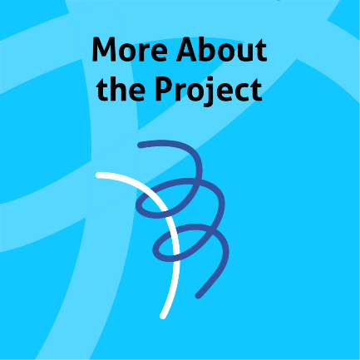](https://ercdancing.maynoothuniversity.ie/dancing/more-about-the-project/)

[](https://ercdancing.maynoothuniversity.ie/dancing/project-overview-and-work-packages/)

[](https://ercdancing.maynoothuniversity.ie/dancing/about-erc-project-dancing/values/)

[](https://ercdancing.maynoothuniversity.ie/publications/)

[](https://ercdancing.maynoothuniversity.ie/resources/)

**Why are we doing research into disability and cultural diversity in EU Law?**

We believe that:

* Everyone has a right to take part in the cultural life of the community and to enjoy the arts.
* People with disabilities are frequently not able to take part in art and culture.
* When people with disabilities take part in art and culture, we all benefit.
* Cultural diversity is a value in the EU, and people with disabilities participating in culture will increase cultural diversity.

We aim to challenge the cultural exclusion often faced by people with disabilities and to contribute to the creation of a more inclusive society.