 | Report - The ERC DANCING Mid-Term Academic Conference  – Easy-to-Read Version
 | On 4th September 2023, the DANCING project held a conference and a concert.  A conference is a big meeting where people come together to talk about important topics, share ideas, and learn from each other.
What Is the Goal of this Report?

 | We want to tell you:
 | - What we discussed at the conference.
 | - About the advice that we received from experts on how to make the research better.
 | - How we made the conference and the concert accessible for everyone.
What Is the DANCING Project About?
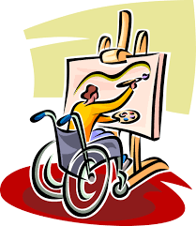 | The DANCING project started in September 2020 and will finish in August 2025.  It is about helping people with disabilities take part in cultural activities (like music, art, and dance).
 | It also looks at how European Union (EU) laws can support fairness and diversity.
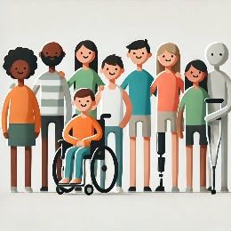 | Diversity means including people from all backgrounds, abilities, and experiences so everyone feels welcome.
What Is the DANCING Project Trying to Do?

 | The project has three main goals:
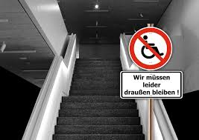 | - Understand Challenges: Learn what stops or helps people with disabilities join in cultural activities.
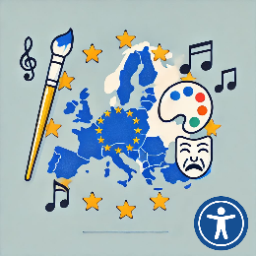 | - Link Culture and Law: Study how EU laws protect the rights of people with disabilities and support diversity.
 | - Thinking of new ideas about cultural diversity as an important rule for the EU.
What Were the Goals of the Conference?

 | - Share Progress: The team explained what they have done and learned so far.
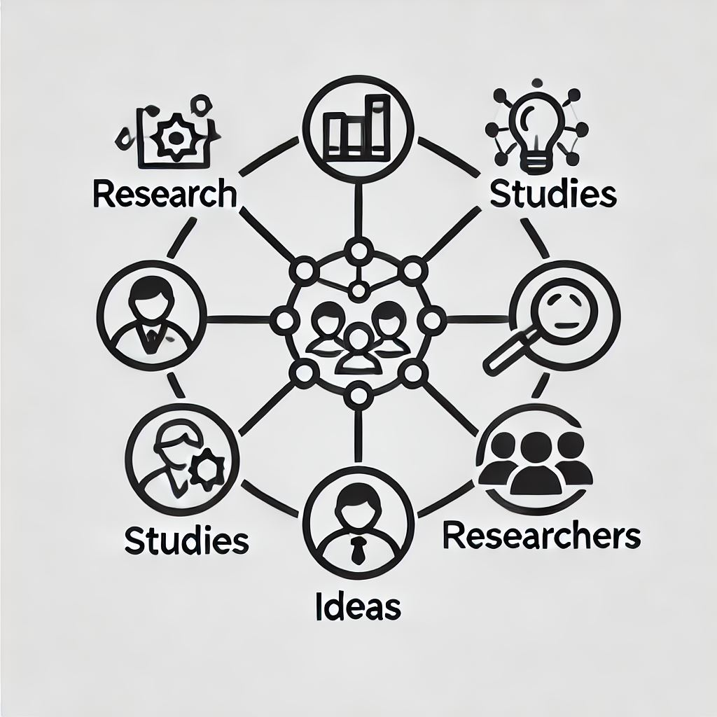 | - Link our research with other studies, ideas and researchers.
What Happened at the Conference?
 | Morning Session:
 | - Talked about laws in the EU that protect people with disabilities.
 | - Talked about how different researchers can work together to make better research.
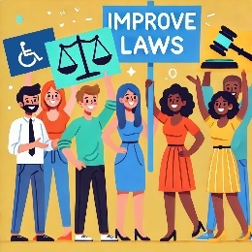 | - Shared ways the project could help improve laws to help people with disabilities.
 | Afternoon Session:
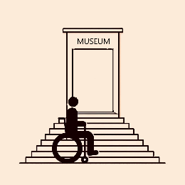 | - Shared early findings about what makes it easier or harder for people with disabilities to join in cultural activities.
 | - Had a group discussion about using arts in research. Arts can include dance, music and art.
 | - Keynote Speech: The meeting ended with a talk by Professor Gráinne De Búrca, an expert in EU law.
 | Accessible Concert: The team held a concert that was designed to include everyone that included artists with disabilities.
Why Was the Conference Important?
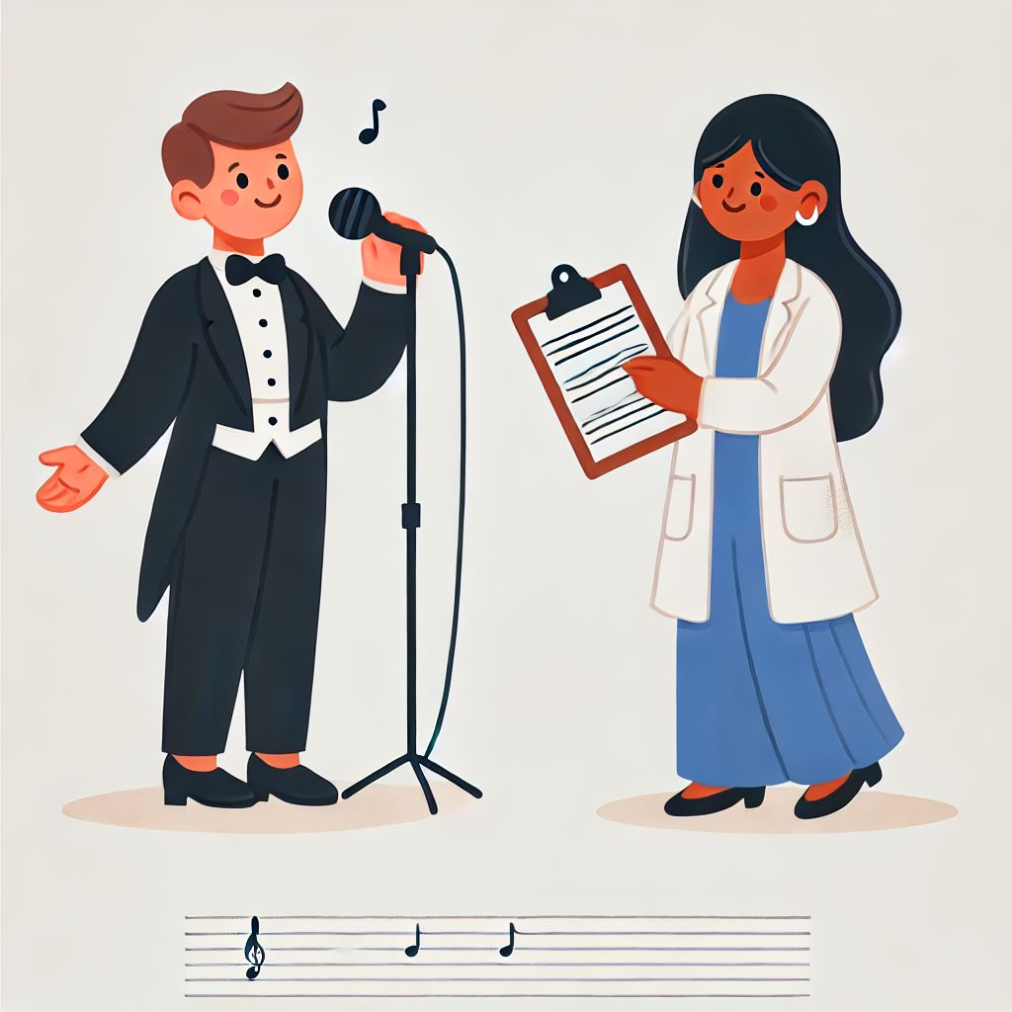 | - The conference was a part of the project by using different ways to share our work.  We had academic talks, but also used art to find new ways to understand and solve problems.
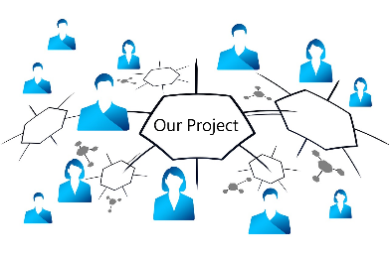 | - To show the project’s ideas and help others know about the DANCING project.

