  What Is this Report About? | Report - Role and Findings of Arts-based Research in the DANCING Project ‘…Usually in the world it is the other way around…’  Easy-to-Read Version
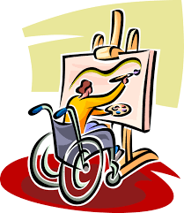 | This report is about a research project called DANCING.  In this project we used arts-based methods to better understand how people with disabilities can take part in cultural activities, like dance, and how this can improve cultural diversity.  We want to tell you how we did this.
What Is the DANCING Project?
 | DANCING has three main goals:
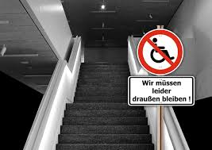 | - Understand Challenges: Learn what stops or helps people with disabilities join in cultural activities.
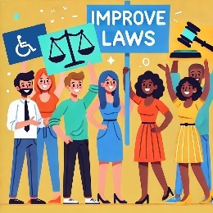 | - To explore how European laws can better support cultural participation and fight discrimination.
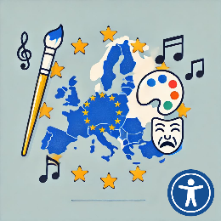 | - To develop new ideas about cultural diversity in Europe.  Cultural diversity means people with different language, food, music, traditions, and beliefs, all living in the same place.
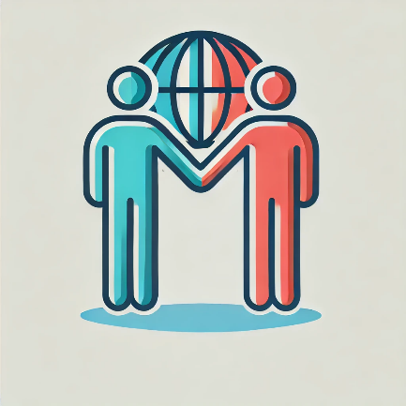 | This project is guided by a world-wide agreement called the UN Convention on the Rights of Persons with Disabilities (CRPD).
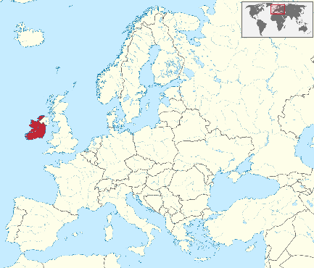 | The project is based at Maynooth University in Ireland.  The project started in 2020 and will finish in 2025.
What Is Arts-based Research?
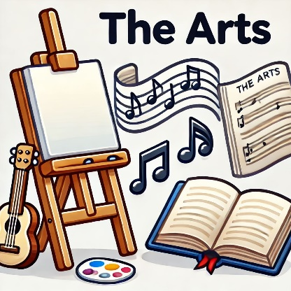 | ‘Arts’ includes activities like dance, painting and music.
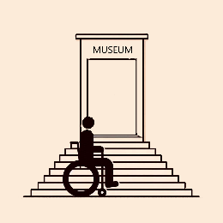 | In this project we have used arts-based research to learn about:  - What stops people with disabilities from enjoying and participating in the arts.
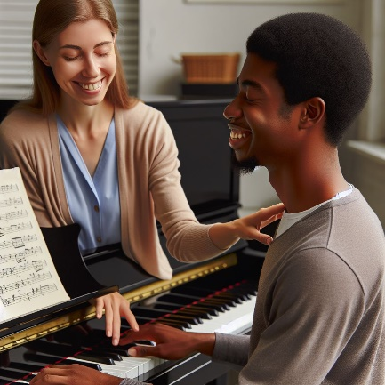 | 2. What helps people with disabilities to enjoy and participate in the arts.
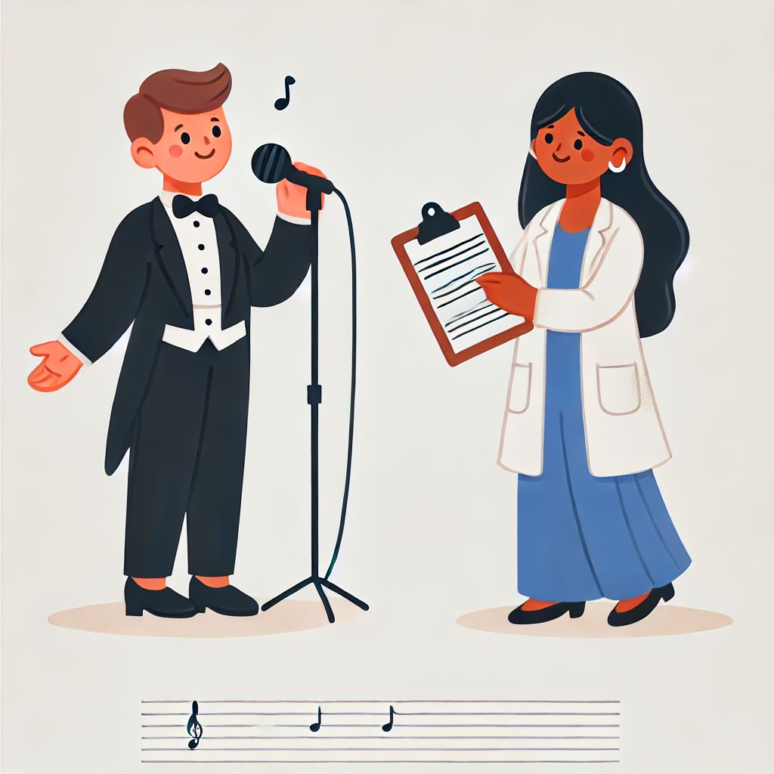 | Arts-based research is a type of research that uses methods and ideas from the arts.
How Did the DANCING Project Use Arts-based Research?
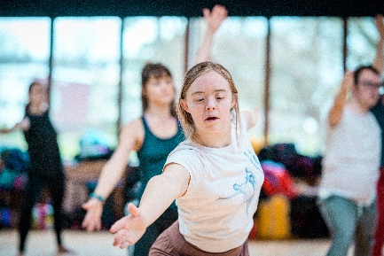 | We worked with an inclusive dance group called Stopgap Dance Company.  Some of the dancers had a disability and some did not.
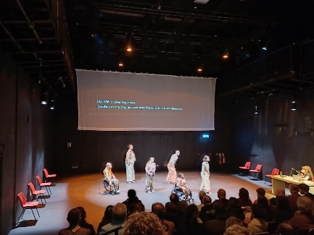 | Stopgap created a dance performance called ‘Lived Fiction’ for our project.
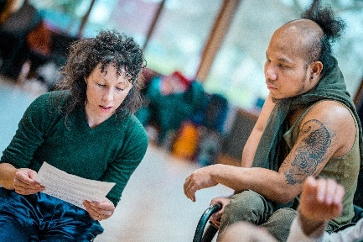 | Dancers with and without disabilities took part in creating the dance.
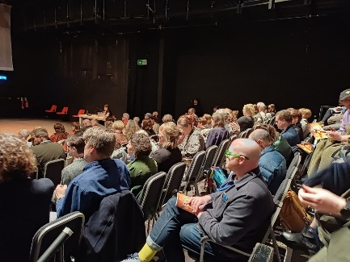 | We worked with Stopgap to make sure people with disabilities in the audience were able to enjoy the performance as well.
 | As part of this research:
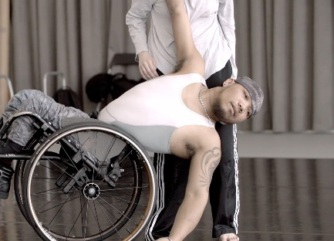 | - we watched rehearsals and performances.
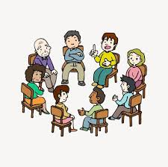 | - We talked with the individual dancers about the creation process.  - We discussed the dance piece with audience in a group.
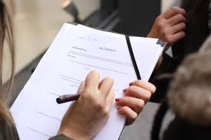 | - we asked audiences to fill out a survey.
What Did We Learn?
- Barriers to Professional Dance:
Dancers with disabilities face many challenges, like:
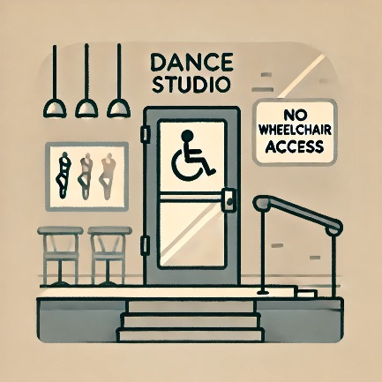 | - Lack of access, including accessible dance spaces or inclusive teaching methods.
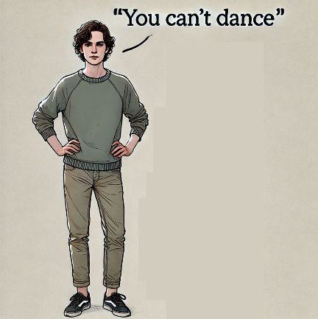 | - Negative attitudes and limited understanding of disabilities in dance education and companies.
 | - Creating ‘Lived Fiction’:
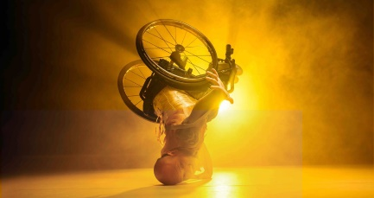 | - When thinking up the dance moves, the unique strengths of each dancer were used.
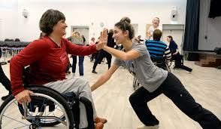 | - Movements were adapted and shared so that everyone could participate fully.
 | - Accessibility (like audio description) was included from the start, making the performance enjoyable for all.
 | - Audience Experience:
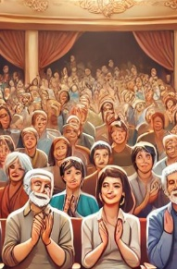 | - People appreciated the efforts to make the performance accessible.
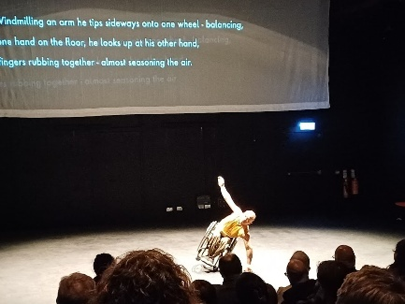 | - Some people liked the performance better because of the accessibility features, like audio description.

Why Does This Matter?
 | The findings show:
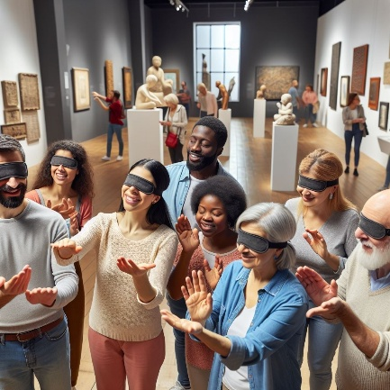 | - Making cultural activities like dance accessible is great for everyone, not just for people with disabilities.
 | - How to include people with disabilities in creative work.
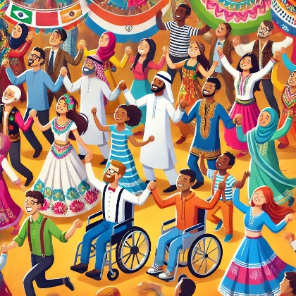 | - Including people with disabilities in creative work is also a way to promote cultural diversity.

Thanks to Stopgap Dance Company for letting us use their photos.

